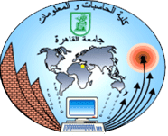

Cairo University

Faculty of Computers and Information

Department of Computer Sciences

Disease Prediction System

Supervised by

Dr. Hesham Ahmed Hassan

TA. Sabah

Implemented by

|  |  |
| --- | --- |
| 20150037 | Ahmed Mohamed Abbas |
| 20150032 | Ahmed Mohamed Ahmed |
| 20150003 | Ibrahim Mohamed Ibrahim |
| 20150013 | Ahmed Samir Mohamed |

Graduation Project

Academic Year 2018-201

Final Documentation

Contents

1. Problem Definition 5

2. Motivation 5

3. Project Objective 5

4. Project development methodology 6

5. Techniques 6

6. Gantt chart for project time plan 7

7. Report organization 8

Background 9

Introduction 9

1. Closest Projects 11

1.2 Api Medic 11

1.2 Web MD 12

1.3 MAYO Clinic 14

2. Advantages 16

3. Disadvantages 17

4. The Difference 17

5. References 18

1. Project specifications 19

1.2. System architecture: 19

2. Stakeholders 22

3. Functional Requirements 22

1. User Register 22

2. User login 22

3. Select gender (if not logged in) 22

4. Select Symptoms 22

5. Answer questions related to your condition 22

6. Disease prediction 22

7. Suggesting medical tips 22

8. Suggesting to see specialist 22

9. Find nearby hospitals using API 22

10. Logout 22

4. Non-Functional Requirements 23

Modifiability: 23

Portability: 23

Reliability: 23

Security: 23

Usability: 23

5. Use Case Diagram 24

6.System test cases 25

1. System Component Diagram 30

2. Sequence Diagrams 31

3. Project ERD 32

4. System Class Diagram 33

5. System GUI Design 34

**Abstract**

Medical diagnosis is the process of determining the disease that explains a person's symptoms. The disease diagnosis system will assist in providing expert health care to remote locations that lack staff and to provide emergency care. People living in rural areas have to travel a long distance to consult a doctor. Using our project will reduce the unnecessary transfer of the patient, while avoiding the cost of transportation from a remote site. Also not all patients have the opportunity to be diagnosed by experts. So what we need is to store the expertise of the data group specialists through the use of (ES) technology. The patient can be diagnosed with just one click, and then it will serve as a medical field. The system provides health care and patient diagnosis and provides health advice on the disease. After that, the patient can consult a specialist if necessary.

Chapter 1: Introduction

## Problem Definition

The problem came from lack of medical facilities in rural areas. Patient living in rural areas have to travel long distances for getting treatment. For example, people suffering from headache or cough, having fever, minor injuries, pain in the joints, etc. have to travel a long distance to consult to a doctor. Our project will help them to diagnose their minor diseases similar to consultancy of doctor with just one click.

## Motivation

We have got motivated from lack of medical facilities in rural areas. Patient living in rural areas have to travel long distances for getting treatment. For example, people suffering from headache or cough, having fever, minor injuries, pain in the joints, etc. have to travel a long distance to consult to a doctor. Our project will help them to diagnose their minor diseases similar to consultancy of doctor with just one click. We have also got inspired for opting for this project from the people who travel daily long distance for their job or daily chores. So they don’t get time for proper medication or even to visit a doctor. As a result they face health issues by not getting proper treatment. Also people get wrong recommendation of medicine, leading to more severe problems. This project will help people to get treatment on time and to get accurate medicine for their symptoms.

## Project Objective

Build a consumer-focused integrated primary health care system; Improve access and reduce inequity, Increase the focus on health promotion and prevention, screening and early intervention; and. Improve quality, safety, performance and accountability.

The objective is to collect information and data to make better decisions and outcomes to patients (customers) and facilitate healthcare processes. and can manage the relationship between a healthcare provider and its patients in order to create a greater mutual understanding, trust, and patient involvement in decision making.

To sum up, healthcare systems are complex sociotechnical systems in which many information system innovations fail because of problems in planning or design. One of the reasons for this is that traditional analysis methods were designed for stable, relatively simple systems and single users. New analytical approaches are needed that can encompass the complexity of changing systems and multiple, interacting users. It sometimes appears that creating and implementing a healthcare information system may be more complex than putting a man on the moon

## Project development methodology

Agile is best suited for our project , because The key features of agile are its short-termed delivery cycles (sprints), agile requirements, dynamic team culture, less restrictive project control and emphasis on real-time communication.

## Techniques

In medical diagnosis process, database management systems (DBMS) are used for storing, retrieving and manipulating patient data.

Server-side scripting language for web development (python) to deal with user requests from client side (flask library).

Markup language for creating web page User Interface (HTML / CSS / JavaScript).

Machine learning (ML) algorithm to manipulate and classify the data to reach the most appropriate diagnosis (Python libraries will be used).

The system starts with asking the patient about symptoms, if the system is able to name the disease then it provide the name, otherwise it redirects the patient to provide more symptoms of the disease.

## Gantt chart for project time plan

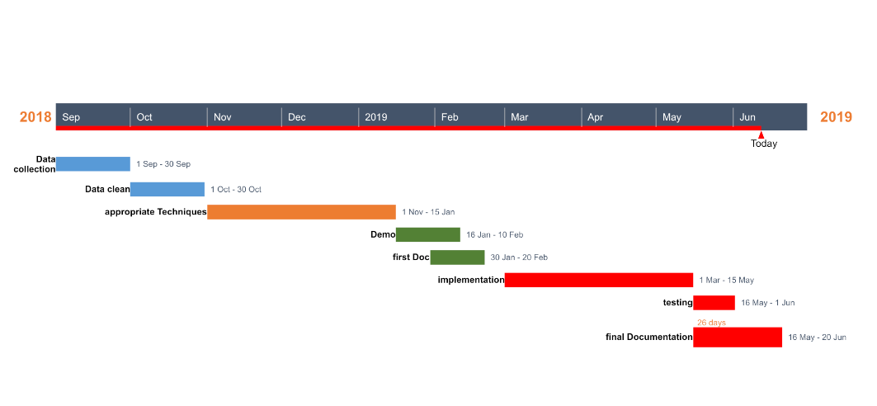

## Report organization

## Background

## Introduction

Disease diagnosis is the process of determining which disease or condition explains a person’s symptoms and signs. The information needed for diagnosis is typically collected from a history and physical examination of the patient. The main goal is to provide the expert-based health care to rural areas developing countries where the doctors are not easily available. Also the other areas where there is need for uniform health-care access include remote military bases security health-care facilities. The idea of this project is to act as a facilitator by recording all the data entered by the patient i.e. symptoms entered by the user and case history given by the user’s and to diagnose the diseases of patient to greater extent if possible and help them cure their disease by consulting with experts. Medical care will be delivered easily to the patient. This could reduce cost of patient for visiting doctors or to consult the doctor will also save the time of the patient.

Providing the right care, to the right patient, at the right time is not only the definition of providing quality healthcare, but also the key to the long-run viability of healthcare system. In this sense, personalized healthcare information system is emerged that maintain relationship between patients and doctors individually.

In chapter 2 :

will explain related work and some of closest examples from our project.

advantages ,disadvantages and differences between our project and other of related works.

In chapter 3:

Will explain project specification (function and non function requirements).

Use case diagrams and system test cases.

In chapter 4:

Will explain diagrams of system(class, component and sequence).

Then project ERD and GUI design.

In chapter 5:

System running and samples of the applied test cases shown in chapter 3.

Chapter 2: Related Work

## Closest Projects

### 1.2 Api Medic

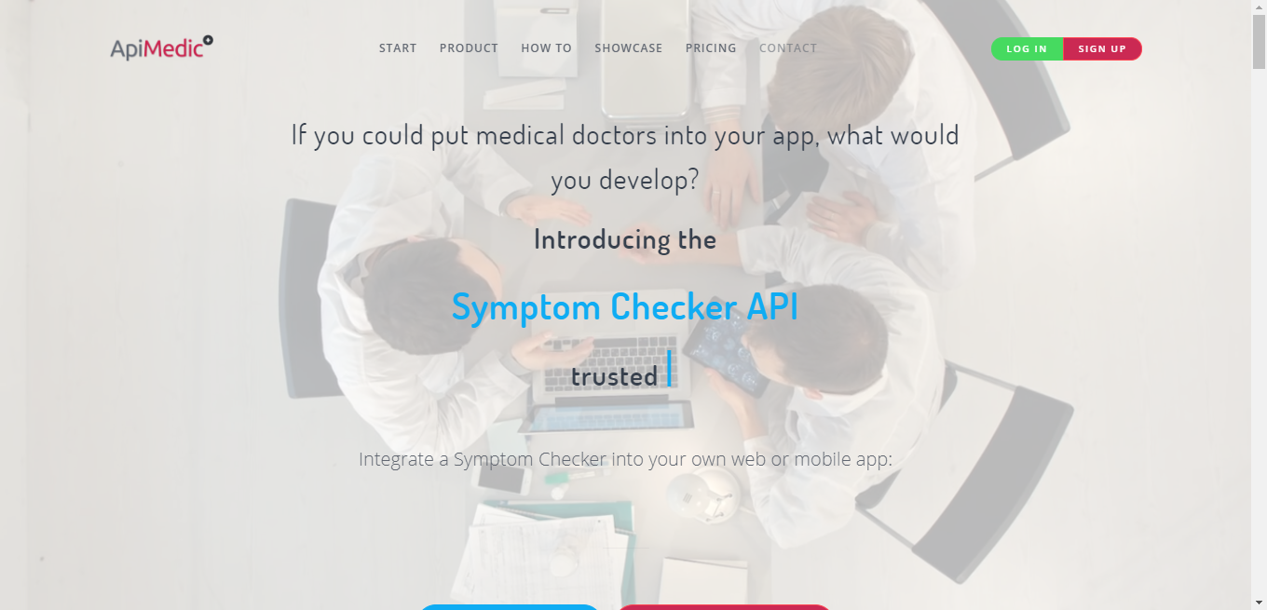

### 1.2 Web MD

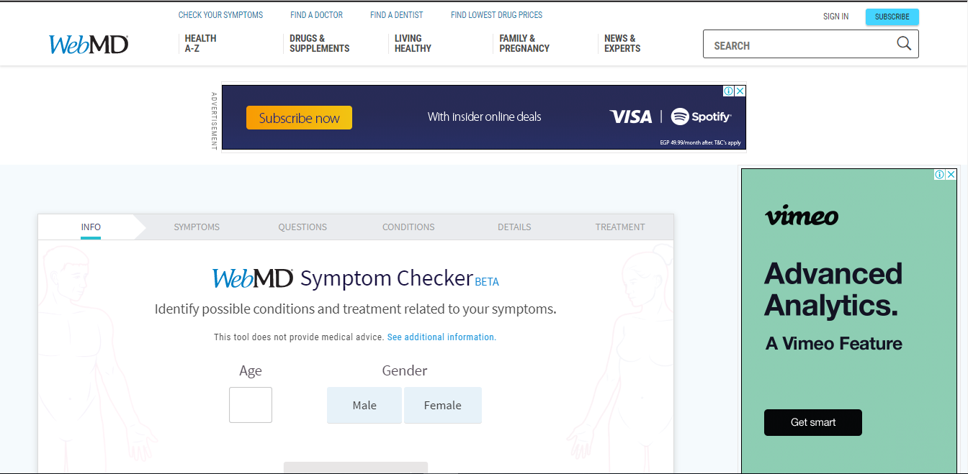

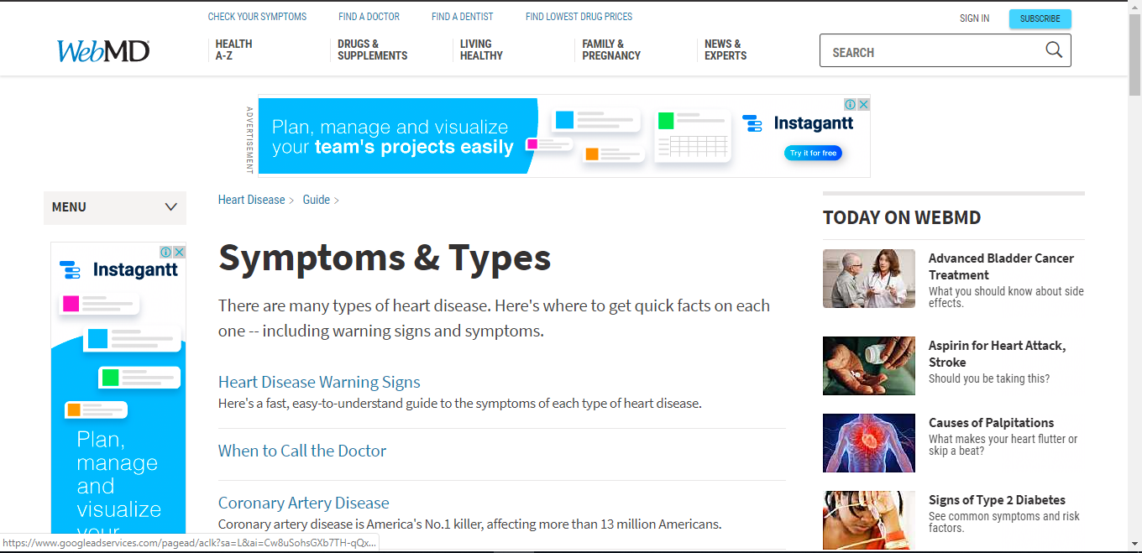

### 1.3 MAYO Clinic

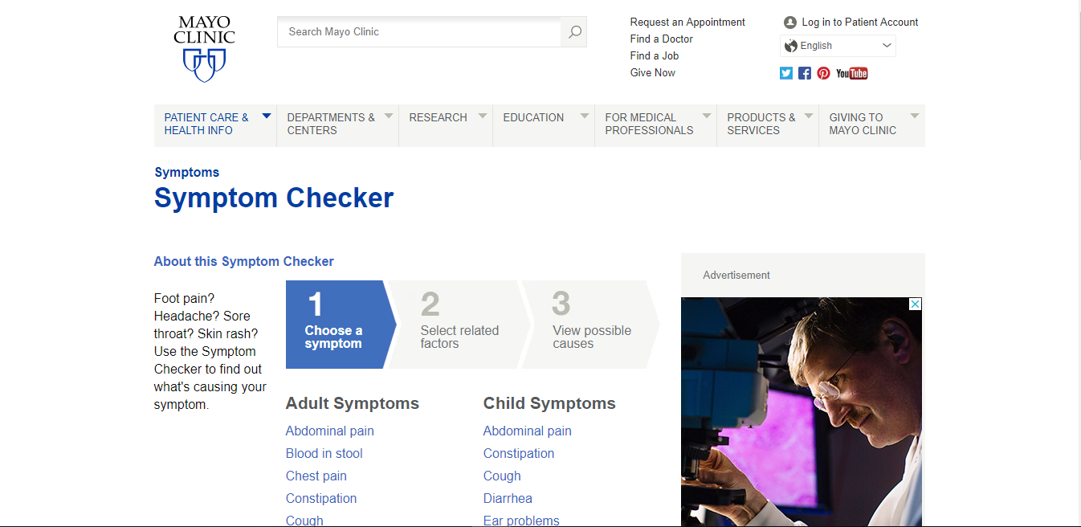

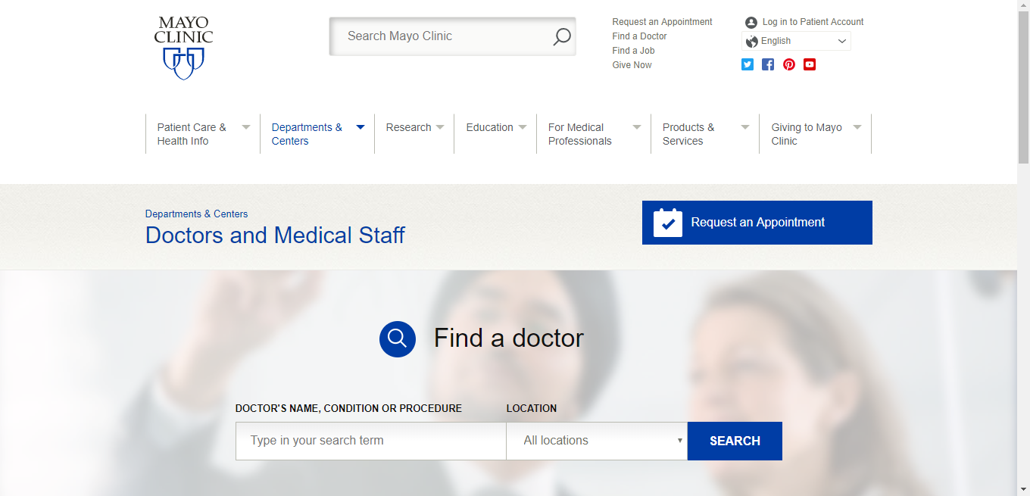

Whenever we come across any disease or we feel ill, the first priority is to search the treatment and precautions online using google search tool. There is no rocket science involved but this is the natural phenomenon that hits the mind first. This whole process is termed out as “Self-diagnosis”. It would never be wrong to say that internet really helps in terms of diseases as it enclosed immense useful articles. Other than the self-diagnosis, here we would like to mention “Online medical diagnosis system” that greatly impressing the population and they prefer to have direct doctor consultation using the internet. The way of diagnosis has effectively minimized the human effort, now patient by staying at home can easily talk to the doctor and can have the possible precautions with respect to the symptoms. Anyhow, when it comes to diagnosis by using self-diagnosis techniques you might have heard about “[Online Medical Symptoms Checker](https://clinic-tcm.com/?page_id=43)“, it is another great tool to detect the disease. let us discuss it!

## 2. Advantages

Probably, it is one of the easiest ways to get diagnosed just by sitting in front of your smart device.

It is providing great online support, the website like WebMD.com has introduced this and used by the number of users for the consultations.

Not all can afford the doctor’s fees and bills hence, the self-diagnosis using the internet has the potential to solve this issue.

For sure, it is the quick, easiest and comfortable process to diagnose one without waiting for the weeks till the report comes.

Patient can type his symptoms and get a quick and easy diagnosis of whatever ailment is bothering you without getting a doctor’s bill.

It saves you money, time and worries over going to a doctor’s office. For people who are scared to go to the doctor, or need to save their money, this can be a saving grace.

## 3. Disadvantages

Not all users are sure about the information they are putting while utilizing the [symptom checker online](https://clinic-tcm.com/?page_id=43). Most of us do to talk to the doctor.

We know that world has progressed in terms of technologies, anybody can hack the respective page and can edit the symptoms details which hurt the patients rather giving a sort of benefit.

Not all existing online symptoms checkers give same results, hence doctor consultation is preferable.

In order to use this tool, you must have in-depth learning about the information you suppose to add by considering the words, for example, you must be known to the difference between “Chronic Headache” and “A severe Headache” because if you get confused in these terms the outcome may be affected.

Aside from the easiness, and the amount of money it could save you, self-diagnosis can be dangerous for your health.

For one reason, you could be only seeing the tip of the iceberg with some of the symptoms a patient could be feeling.

Some diseases or conditions show themselves through symptoms that are common with simple sicknesses, like the flu or the common cold.

## 4. The Difference

Our project do the same things, the Difference that our project provide service that able the patient to direct him/her to specific specialist or nearby hospital if the case very dangerous, and this site provide treatment our project don't provide this serve but it provides some general medical tip.

## 5. References

<https://apimedic.com/>

<https://symptoms.webmd.com/default.htm#/info>

<https://www.mayoclinic.org/symptom-checker/select-symptom/itt-20009075>

<https://symptomchecker.isabelhealthcare.com/suggest_diagnoses_advanced/landing_page>

Chapter 3: System Analysis

## 1. Project specifications

### 1.2. System architecture:

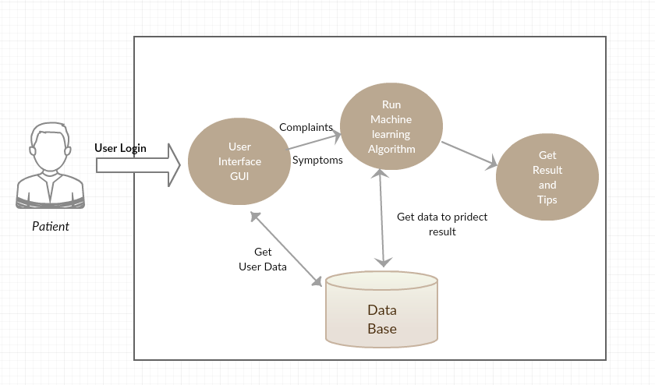

Figure 3.1: System Architecture of Disease Diagnosis System

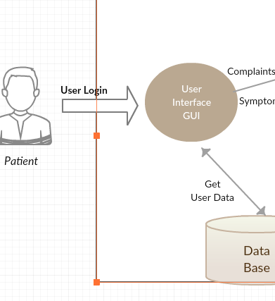

Figure 3.2: System Architecture of Disease Diagnosis System

This figure explains if user log in to system will has features more than if not login.

If log in user can be find his history of diagnosis.

This features like find nearest hospital and can contact with Doctors.

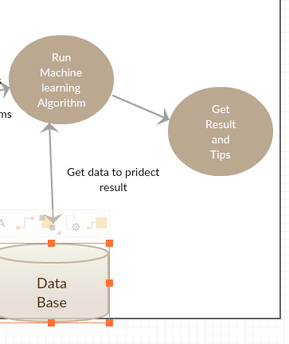

Figure 3.3: System Architecture of Disease Diagnosis System

this figure explains after user enter complaints and symptoms algorithms of ML will get data and run to predict diseases.

Then for all diseases are predicted system will suggest some info and tips for all diseases.

Finally, if you want to know the nearest hospital search in map.

## 2. Stakeholders

Project Manager Dr. Hisham Hassan who is responsible of managing the project and stakeholder’s expectations.

Project Team members the group performing the work.

Customer/User person or organization that will use the results of a project. There may be multiple layers of users (.i.e. patient, doctor ).

## 3. Functional Requirements

### 1. User Register

### 2. User login

### 3. Select gender (if not logged in)

### 4. Select Symptoms

### 5. Answer questions related to your condition

### 6. Disease prediction

### 7. Suggesting medical tips

### 8. Suggesting to see specialist

### 9. Find nearby hospitals using API

### 10. Logout

## 4. Non-Functional Requirements

### Modifiability:

Requirements about the effort required to make changes in the software. Often, the measurement is personnel effort (person- months).

### Portability:

The effort required to move the software to a different target platform. The measurement is most commonly person-months or % of modules that need changing.

### Reliability:

Requirements about how often the software fails. The measurement is often expressed in MTBF (mean time between failures). The definition of a failure must be clear.

### Security:

One or more requirements about protection of your system and its data. The measurement can be expressed in a variety of ways (effort, skill level, time ...) to break into the system. Do not discuss solutions (e.g. passwords) in a requirements document.

### Usability:

Requirements about how difficult it will be to learn and operate the system. The requirements are often expressed in learning time or similar metrics.

## 5. Use Case Diagram

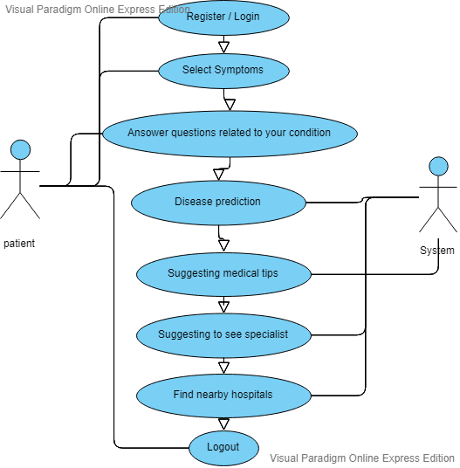

Figure 3.4: Use Case Diagram

## 6.System test cases

Table 3.1 : Log In Test case

|  |  |
| --- | --- |
| **Use Case Name** | Log In |
| **Use case Description** | A user login to System to access the functionality of the system. |
| **Actors** | patient |
| **Pre-Condition** | System must be connected to the network. |
| **Post -Condition** | After a successful login user can write his complaints. |
| **Steps** | 1. Enter username 2. Enter Password |
| **Extensions** | Invalid Username System shows an error message, |
| Invalid Password  System shows an error message. |

Table 3.2 :Complaints Test case

|  |  |
| --- | --- |
| **Use Case Name** | Complaints |
| **Use case Description** | A user enters his complaints to system. |
| **Actors** | patient |
| **Pre-Condition** | System must be connected to the network.  And should answer some question like (age, gender). |
| **Post -Condition** | After complaints system make an interview with patient  To diagnosis carefully. |
| **Steps** | - Log in or answer question of age and gender.  - Enter his complaints. |

Table 3.3 : Interview Test case

|  |  |
| --- | --- |
| **Use Case Name** | Interview |
| **Use case Description** | A system ask patient some related questions according to his complains. |
| **Actors** | patient |
| **Pre-Condition** | System must be connected to the network.  And user should enter his complaints |
| **Post -Condition** | After answer system will predict the result. |
| **Steps** | - log in or answer question of age and gender.  - Enter complains  - Ask some question |

Table 3.4 :Prediction Test case

|  |  |
| --- | --- |
| **Use Case Name** | Prediction |
| **Use case Description** | A system will predict result to patient. |
| **Actors** | Patient, System |
| **Pre-Condition** | System must be connected to the network.  User should enter his complaint carefully.  And answer question that are suggested by system. |
| **Post -Condition** | After a prediction system will show some definitions and some tips to patient. |
| **Steps** | - log in or answer questions of age and gender.  - enter his complaints.  - ask questions of his symptoms. |

Table 3.5 : Nearest Hospital Test case

|  |  |
| --- | --- |
| **Use Case Name** | Nearest Hospital |
| **Use case Description** | A user want to know nearest |
| **Actors** | patient |
| **Pre-Condition** | System must be connected to the network.  User should enter his complaint carefully.  And answer question that are suggested by system.  Enter his Location. |
| **Post -Condition** | System suggests nearest hospitals. |
| **Steps** | - log in or answer questions of age and gender.  - enter his complaints.  - ask questions of his symptoms  - prediction.  - enter his location. |

Chapter 4: System Design

## System Component Diagram

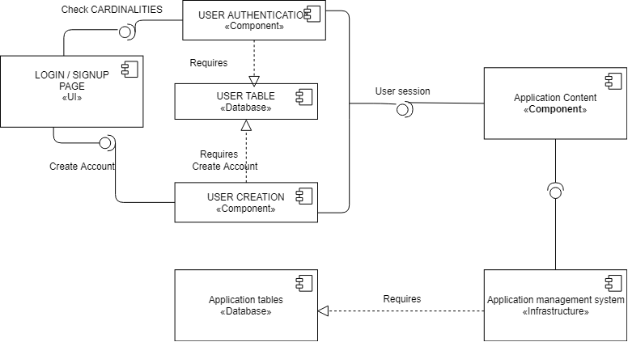

Figure 4.1: Component Diagram

## Sequence Diagrams

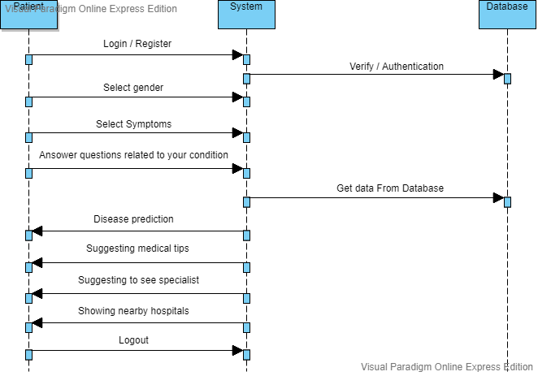

Figure 4.2: Sequence Diagram

## Project ERD

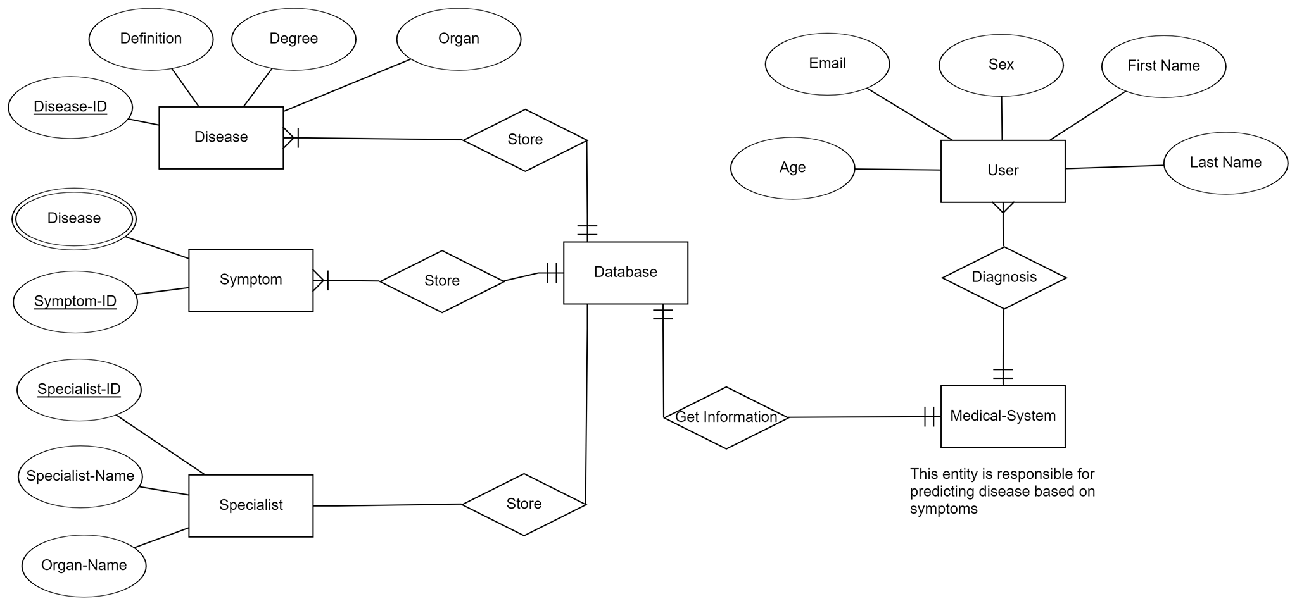

Figure 4.3: ERD Diagram

## System Class Diagram

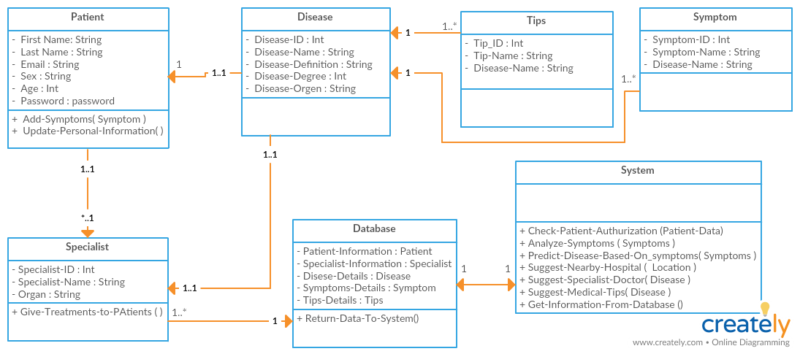

Figure 4.4: Class Diagram

## System GUI Design

5.1.Home page GUI

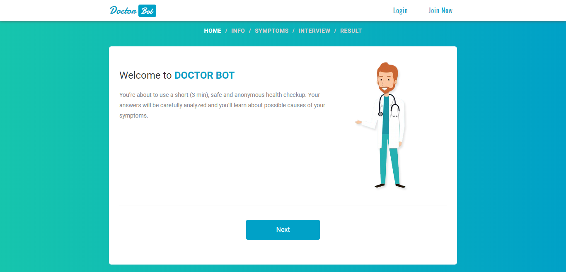

**5.2.INFO page GUI**

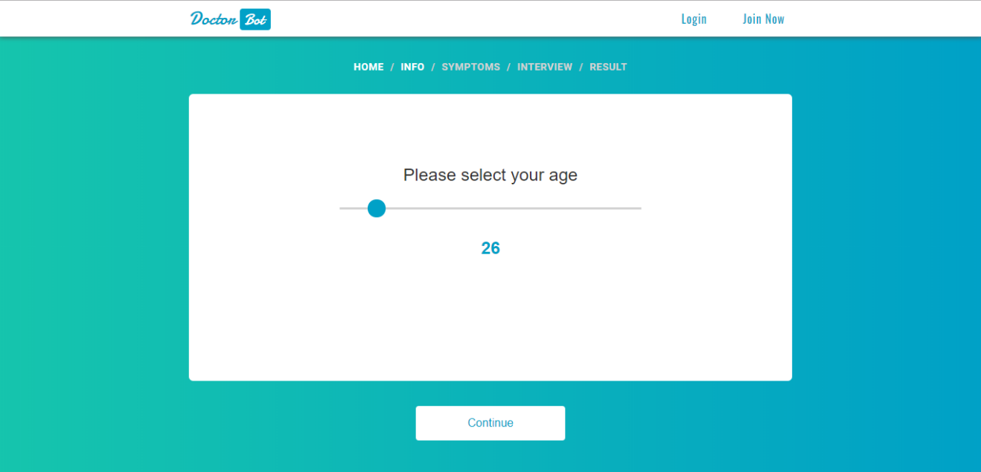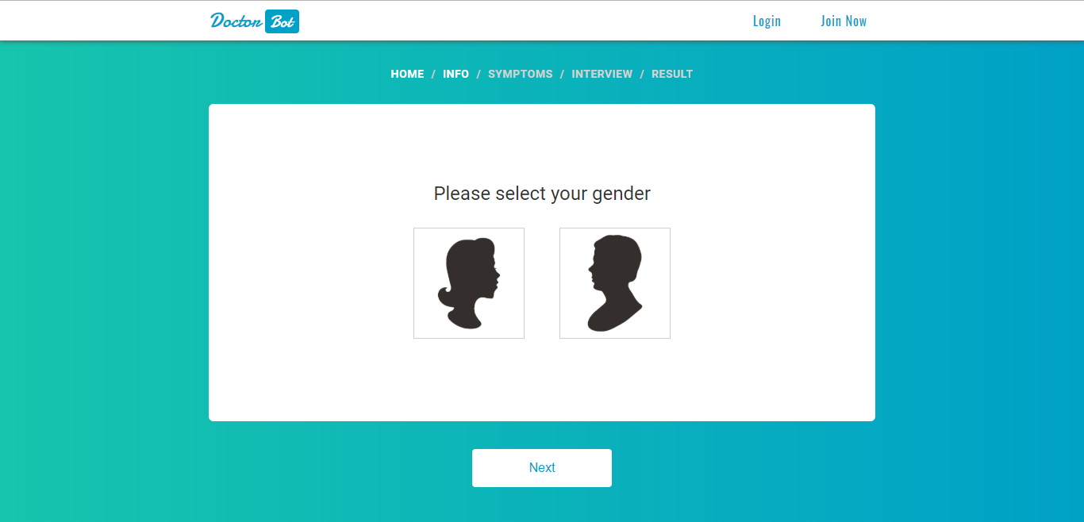

**5.3.Symptoms page GUI**

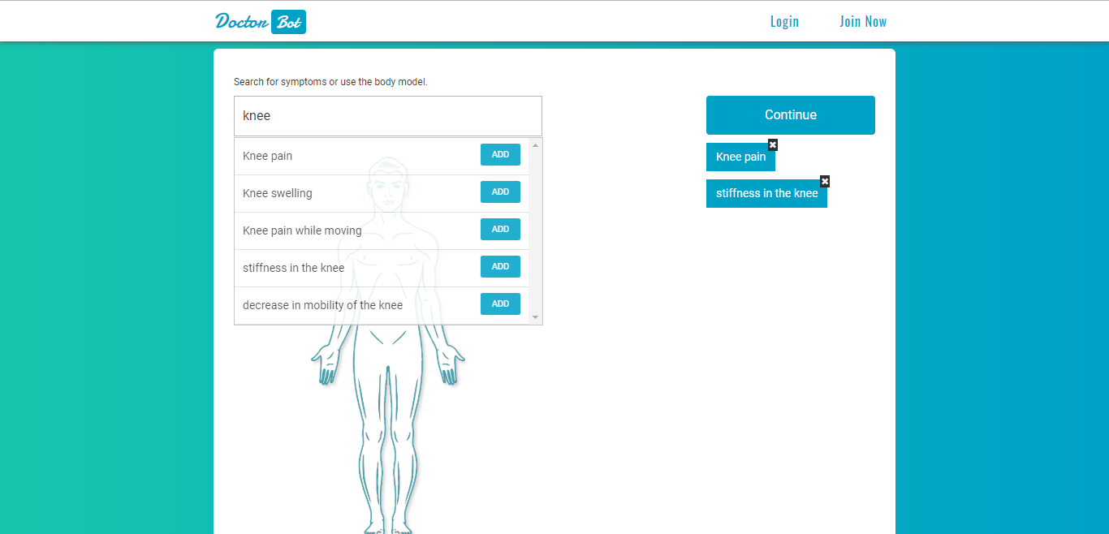

**5.4.Interview page GUI**

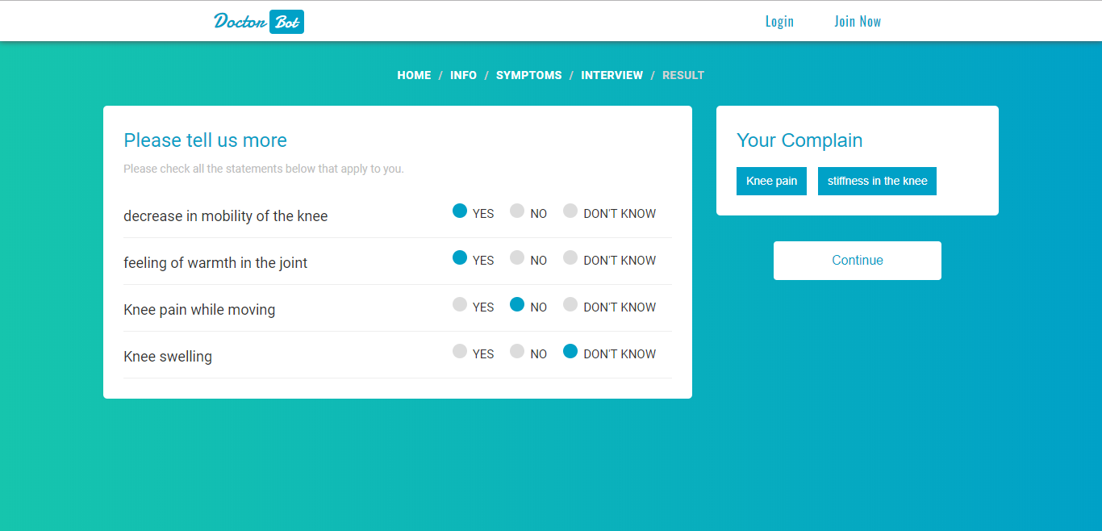

**5.5.Result page GUI**

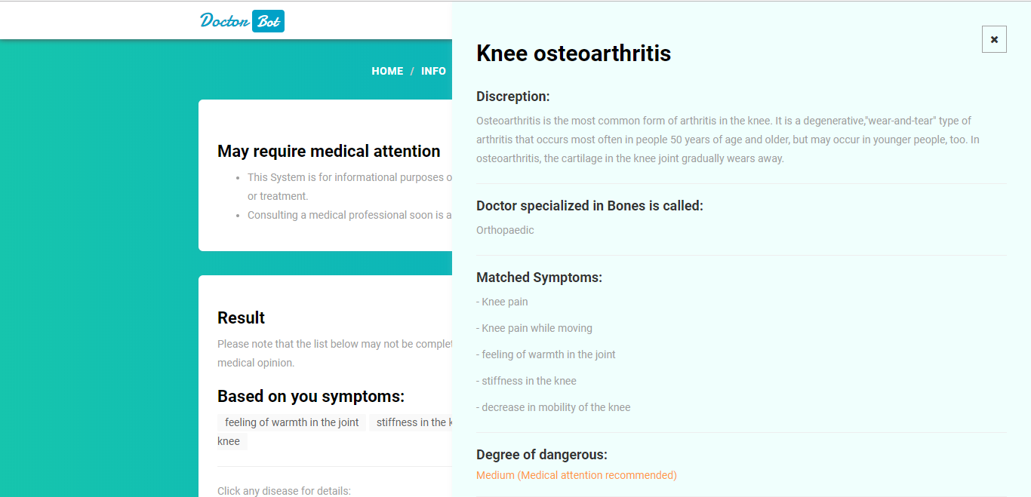

**Chapter 5**

**Implementation**

**Machine code**

**Web design**

**Machine code Algorithms**

**-Naive Bayes algorithm**

**-Decision Tree algorithm**

**-Data Analysis**

**Site Algorithms**

**Html**

**CSS**

**JavaScript**

**Bootstrap**

**Sql**

**Flask**

**Test Case 1**

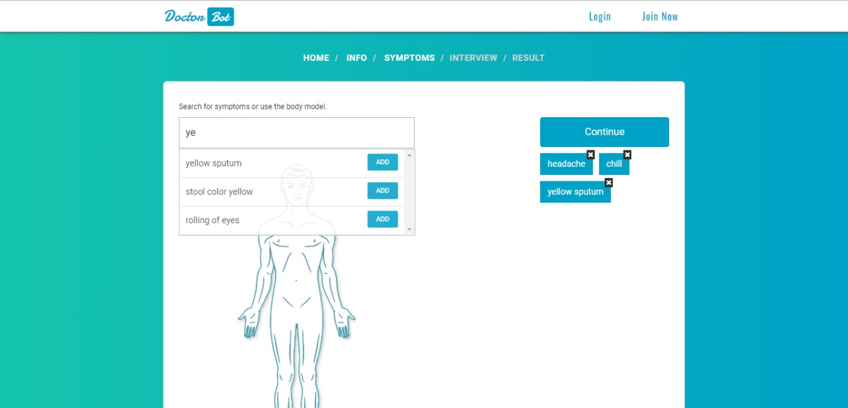

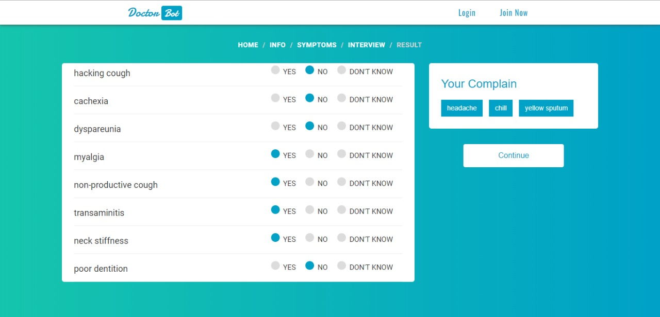

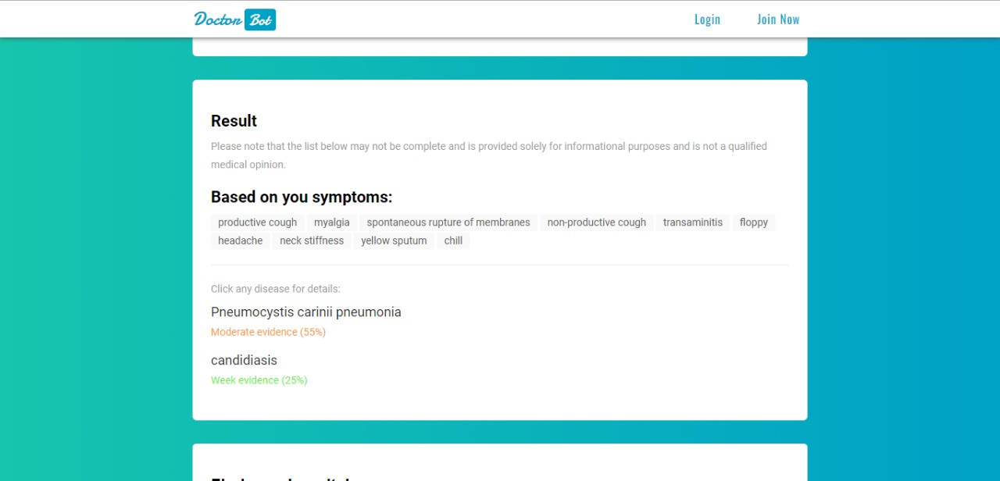

**Test case 2**

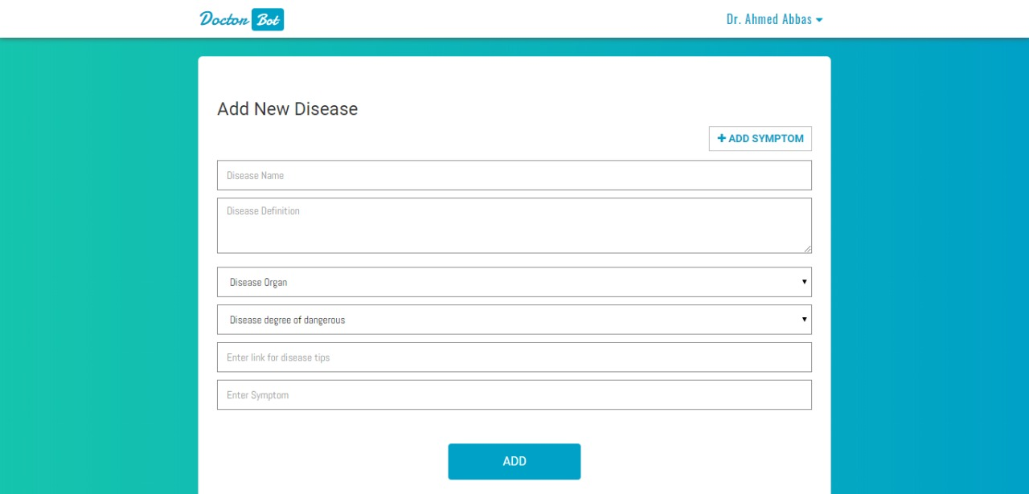

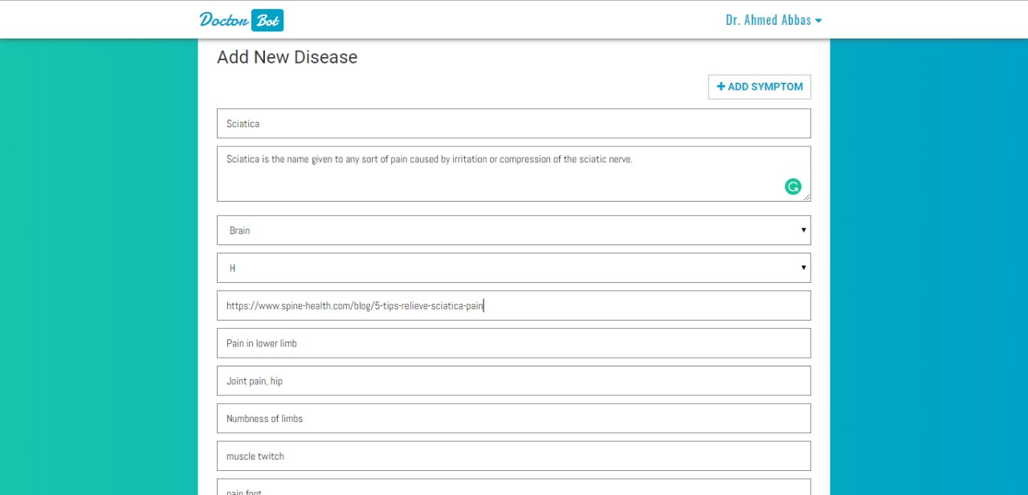

**Test case 3**

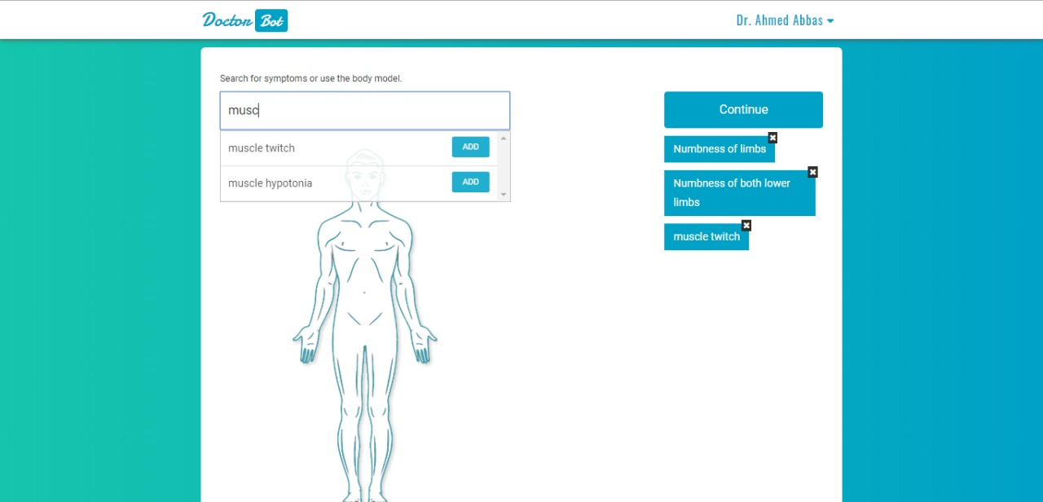

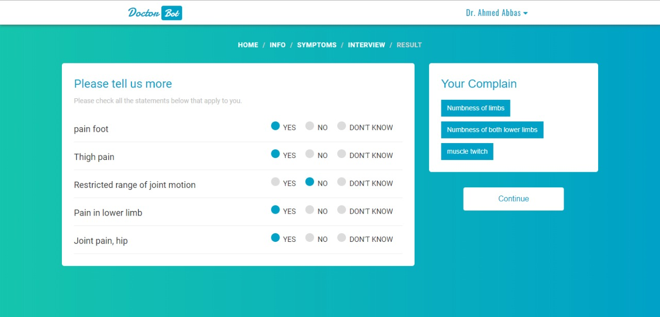

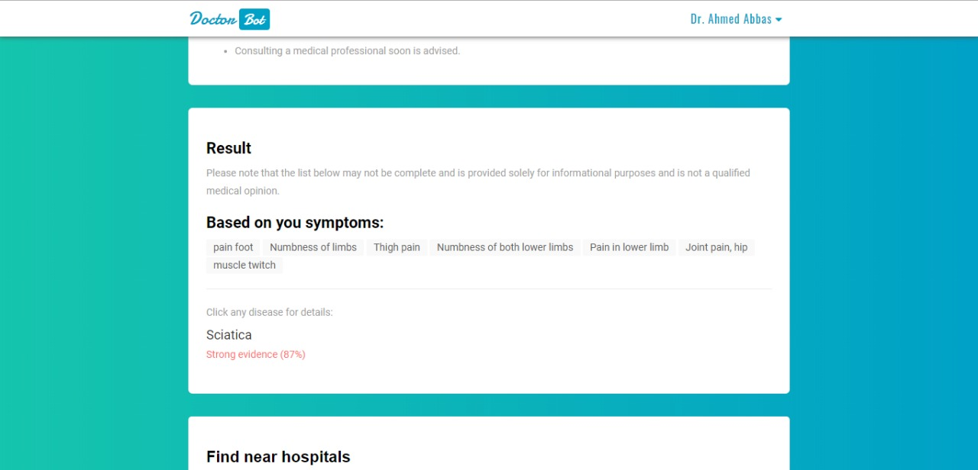 Test case 4

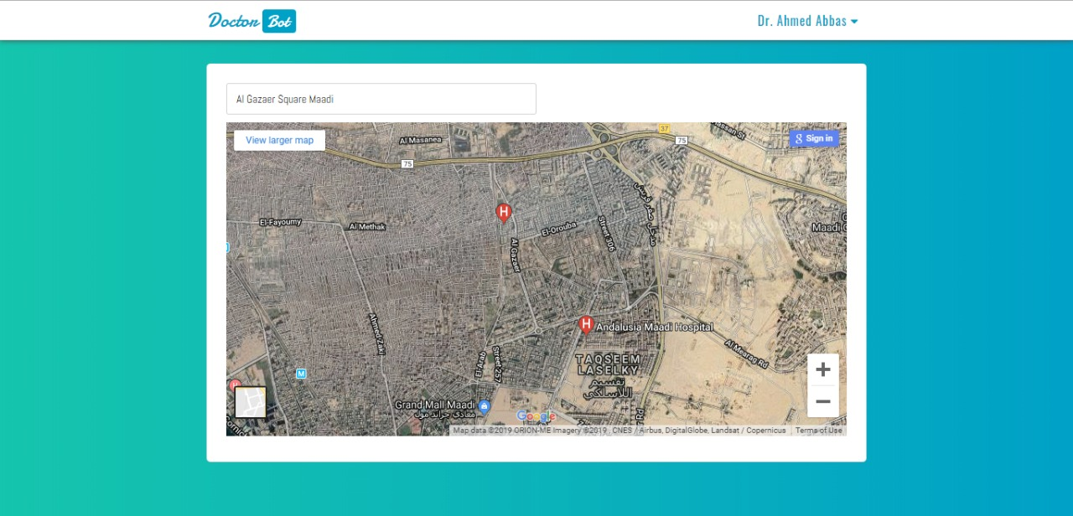

**Test case 5**

